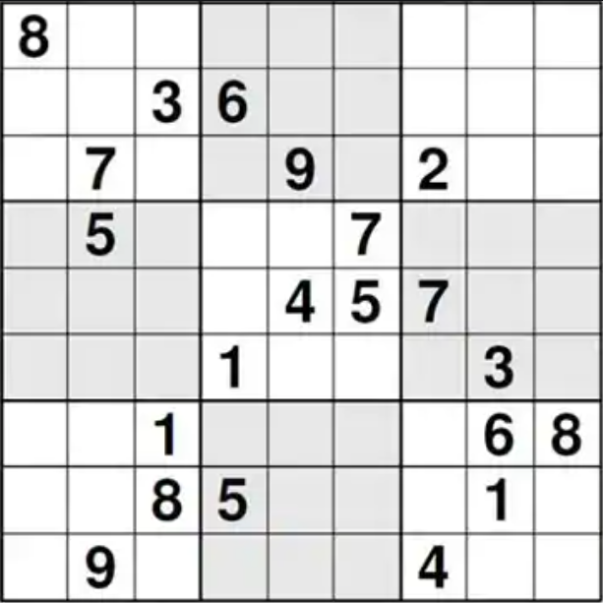
Project: Binary Sudoku
Sudoku-like game called Binary Sudoku.

General Information

The game is played on a 9*9 board. The board will be filled with 10 different game elements by the player. The aim of the game is to fill a row, a column or a 3*3 block with the game elements and reaching the highest score.

Board Elements

There are ten game elements. Each has a 1/10 probability of occurrence. The game elements are given below. (Each X represents 0 or 1, randomly generated)

Number of squares  in game piece | Pieces
Number of squares  in game piece | 1 | 2 | 3 | 4 | 5 | 6
1 | X
2 | XX | X  X
3 | XXX | X  X  X | XX  X | XX  X | X  XX | X  XX
4 | XX  XX

Game Playing Rules

- The game starts with a 9*9 empty board.
- A new piece is generated randomly and displayed on the right of the board.
- The user can place the game element in an empty part of the board without overlaying. Game elements cannot be rotated. Placement operation does not have a time limit.
- If the located element:
- fills a full row(s) (and/or)
- fills a column(s) completely (and/or)
- fully fills a 3*3 block(s),
the fully filled row(s)/column(s)/block(s) are treated as a binary number. The decimal equivalent of binary numbers are calculated.
- If the currently placed game element fills more than one row(s)/column(s)/block(s), the decimal equivalent of binary numbers are added and this sum is multiplied by the number completed parts (row(s)/column(s)/block(s)). This result is added to the score.
- Completed parts are removed from the board.

Game Ending

If there is no suitable space left to place the new piece on the board, a notice appears saying "game is over".

Sample Game Screens

1 2 3 4 5 6 7 8 9 New Piece Score: 134
+-----+-----+-----+
1|0 . .|. . .|. 1 .| 1 0 Piece: 15
| | | |
2|. 1 0|. . .|. 1 .| 1
| | | |
3|. . .|. . .|. 1 .|
+-----+-----+-----+
4|0 0 .|. 1 0|0 0 1|
| | | |
5|1 0 .|. . .|. . .|
| | | |
6|0 0 0|. . .|. . .|
+-----+-----+-----+
7|. . .|. . .|. 1 .|
| | | |
8|. 0 .|0 . .|. 1 .|
| | | |
9|. . .|. 1 0|. 0 .|
+-----+-----+-----+

--------------------------------------------------------

1 2 3 4 5 6 7 8 9 New Piece Score: 504
+-----+-----+-----+
1|0 . .|. . .|. 1 .| 1 Piece: 16
| | | |
2|. 1 0|. . .|. 1 .| 0
| | | |
3|. . .|. . .|. 1 .| 1
+-----+-----+-----+
4|0 0 1|0 1 0|0 0 1|
| | | |
5|1 0 1|. . .|. . .|
| | | | Calculations:
6|0 0 0|. . .|. . .| (001010001)2 = (81)10
+-----+-----+-----+ (001101000)2 = (104)10
7|. . .|. . .|. 1 .| 104 + 81 = 185
| | | | 185 * 2 = 370
8|. 0 .|0 . .|. 1 .|
| | | |
9|. . .|. 1 0|. 0 .|
+-----+-----+-----+

--------------------------------------------------------

1 2 3 4 5 6 7 8 9 New Piece Score: 998
+-----+-----+-----+
1|0 . .|. . .|. 1 .| 0 1 Piece: 17
| | | |
2|. 1 0|. . .|. 1 .| 0 0
| | | |
3|. . .|. . .|. 1 .|
+-----+-----+-----+
4|. . .|. . .|. 1 .|
| | | |
5|. . .|. . .|. 0 .|
| | | | Calculations:
6|. . .|. . .|. 1 .| (111101110)2 = (494)10
+-----+-----+-----+
7|. . .|. . .|. 1 .|
| | | |
8|. 0 .|0 . .|. 1 .|
| | | |
9|. . .|. 1 0|. 0 .|
+-----+-----+-----+

